Table of Contents
Introduction 2
Pipework (HHS/1) 3
Thermal Store 3
Wood Burner 4
Oil Burner 4
Boiler Controller (BC) 4
Diagram Notes Boiler Controller 4
Hardware 4
Software 5
Other Inputs 6
Heating Logic – Central Heating 7
Input Conditions 7
Output Settings 7
Heating Logic – Domestic Hot Water 9
Input Conditions 9
Output Settings 9
Combining CH & DHW Requests to WB and OB 11
Errors & Warnings 11
temperature.c 11
BoilerControl.c 11
io.c 12
user_main.c 12
Cupboard Wiring (HHS/2) 12
JB5 Wiring (HHS/3) 12
DHW 12
Wood Burner Control 12
Connectors (HHS/4) 13
WB Controls (HHS/5) 13
Thermostats (HHS/6) 14
Diagnostics 15
Solar Thermal (HHS/7) 16
Parts 16
Parameters 17
Controls 17
Set Up 17
Monitoring 18
Diagnostics 18

Introduction
These notes are intended to clarify the associated drawings HHS/1-6. The following abbreviations are used:
- WB – Wood Burner
- OB – Oil Burner
- CH – Central Heating (mainly the underfloor)
- TS – Thermal Store
- ZV – Zone Valve
- JB – Junction Box
- DHW Domestic Hot Water
- F&E – Feed & Expansion (Tank)
- BC – Boiler Controller
- AAV – Automatic Air Vent
- HL – Heat Leak
- IoT Manager – Internet of Things (the computer based data connection and control system used to monitor and control the heating etc.)
- MQTT – A protocol used to transmit messages around the IoT system
- MySQL – a database

The system, as installed, was purely electrically controlled (mode A). A monitoring Boiler Controller was added to observe the system characteristics. The final system uses the Boiler Controller to actively control the system (mode B). The wiring has been designed to enable the system to easily be restored to purely electrical control.

This document describes the operation of the heat sources (Oil Boiler, Solar thermal, wood burner and Thermal Store. The interface to these systems is via the IoT Manager as is the programming and control of the radiators and underfloor heating.

Pipework (HHS/1)
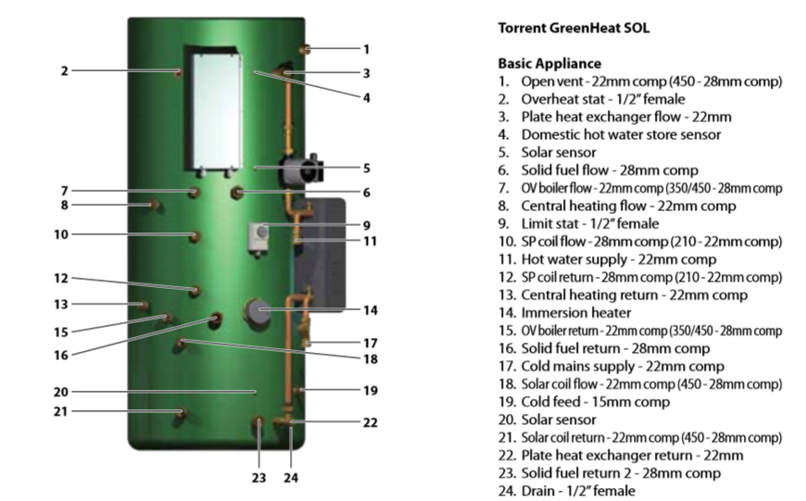

Thermal Store
The core of the system is the Thermal Store (TS – Gledhill Torrent Sol 350l). It stores heat from the Oil Boiler (OB) and Wood Burner (WB) and has a coil to support Solar Thermal panels. It supplies Domestic Hot Water (DHW) via an external heat exchanger.
In mode A, when the WB is not in use, ZV4 is shut and the hot water from the OB is fed directly into the house heating. If the if the DHW is not up to temperature (measured by the cylinder thermostat) ZV4 is opened to allow DHW Flow.
In mode B, the TS is used as a buffer. IE the WB Circulation Pump is used to take heat from the TS. The TS temperature sensors are used to control when to fire the OB to keep the TS up to temperature. Also a delay can be added between firing the OB and starting the OB Pump to minimise the cooling effect of the water in the OB.
The following temperatures are monitored:
- TS Top (4)
- TS Middle (5)
- TS Cylinder (9 – in place of HW stat when in Mode B)
- TS Bottom (20)
- Heating return
- WB Flow
- OB Flow
- OB Return
In mode A they are purely used for monitoring but in mode B they are used as part of the control loop.

Wood Burner
If the WB is in use the Flue Stat, when up to temperature, will open ZV6 and operate the WB Supply Pump. This circuit is described in more detail in the later WB Controls section. The Load Valve will keep this water circulating within the WB until it gets to 61C. In both modes A & B the WB Circulation Pump is used to transfer the heat into the house heating. The WB Supply pump is placed in the return circuit to try to get the Heat Leak feeds somewhere near the neutral point.
The Heat Leak radiator is in the loft with a feed and overflow into a galvanised tank.

Oil Burner
A non return valve is placed in the OB Flow to stop the heat from the TS/WB being wasted just heating up the OB.

Boiler Controller (BC)
The connections to the Boiler Controller for the modes A & B are described in the later section Connectors (HHS/4).
DHW Mode Button
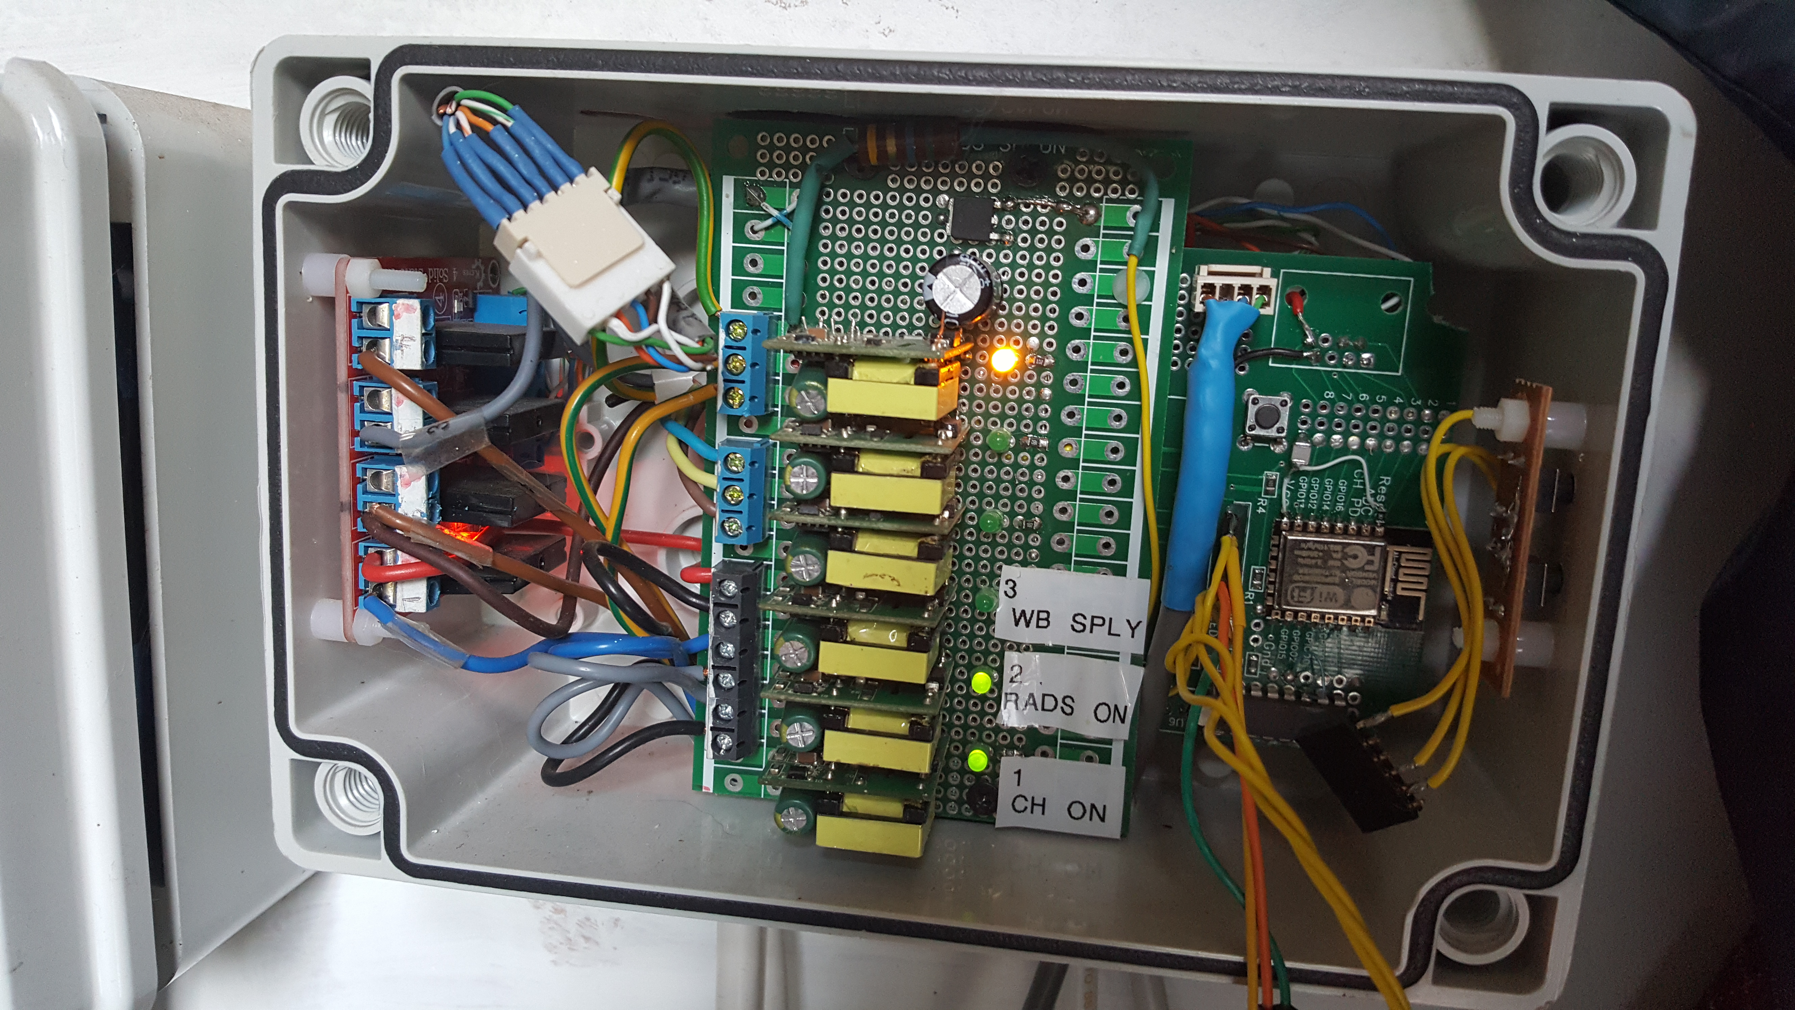
240V Outputs:
4 – Emergency dump
3 – OB Fire
2 – OB Circulation
1 – WB Circulation

CPU & Connector
Reset Button
240V Inputs:
1 – CH On
2 – Rads On
3 – WB Supply On
4 – Family CFH
5 – Lounge CFH

The DHW Mode button enables the user to select one of four modes for the DHW with single presses:
- Normal mode (LED Off) TS Middle sensor is used for DHW temperature. The operating hours are configured in the settings
- Enhanced DHW (LED flashes * 3) TS Cylinder (which is lower down) is used for DHW temperatures
- DHW Off (LED flashes * 1)
- DHW On permanently (LED flashes * 2)
Note that if the button is pressed too fast internal diagnostic functions are invoked.

Diagram Notes Boiler Controller

Hardware
The circuit diagram of the Boiler Controller is entitled Thermal Store CPU. This board has:

- Power supply (3.3V & 5V)
- ESP8266 (ESP-12) cpu with WiFi
- MCP2309 Input/Output extender
- 5 x 240V-5V power supplies that act as the interface to the mains signals
- A 4 way solid state relay to output mains control signals
- Interface to 6 x DS18B20 temperature sensors
- Reset, and User switches
- Connector to allow software uploading and testing

Software
The software has a number of settings used to control how the BC operates:

ID | Setting | E.g. values | Description
0 | DHW Set Point | 60 | The target temperature for the Top of the TS
1 | UFH Set Point | 45 | he temperature of the middle of the TS when the UFH but not the Radiators are calling for heat at which heating (OB or WB) will be used
2 | Rads Set Point | 55 | The temperature of the middle of the TS when the Radiators are calling for heat at which heating (OB or WB) will be used
3 | Set Point Differential | 10 | The additional temperature (to the set point) above which the heating (OB) will be turned off
4 | WB is ON Temp | 65 | The temperature above which it will be considered that the WB is supplying heat
5 | DHW Use all Heat | 48 | (Not currently used)
6 | Outside Temperature Compensation | 5 | The amount the CH set point will be reduced when the Outside temperature is at or above the High Point (currently 20C)
7 | Boost Time | 5 | The time (in minutes) between checking whether a heating boost is required when OTC is applicable
8 | Boost Amount | 2 | The amount the CH set point will be increased each Boost Time if the CH is still calling for heat
9 | Emergency Dump temperature | 88 | The TS Top temperature above which the Emergency Heat Dump signal will be operated. (currently set to operate the Dining Room UFH)
10 | OB Pump ON delay | 0 | The time (in seconds) by which the OB circulation pump is delayed when the OB is turned on.
11 | DHW ON Hour | 7 | The time from which DHW is required
12 | DHW OFF Hour | 22 | The time from which DHW is no longer required
13 | OB Faulty | 0 | Set to 1 if Oil Boiler is not working but need to allow for Immersion Heater and/or Wood Burner to continue to operate (Only versions above 1.0.17), eg stops pumps operating
14 | Invert Outputs | 1 | Depending on the version of the Solid State relay board.  0 – High Level Trigger  1 – Low Level trigger

Other Inputs
A number of other inputs \re taken from the house IoT system using the MQTT protocol::
- Current Time
- Current, 1 hour & 2 hour outside temperature forecast
- The Solar Controller can change the DHW Set Point if it calculates that it can provide sufficient heat.

Heating Logic – Central Heating

Input Conditions
A – WB is Hot
B - Oil Boiler is ON
C - CH CFH
D - Temp Heating Flow >= CH Set Point || TS Middle >= CH Set Point - (Check both TS Middle and Heating Flow and Heating Flow may have cooled)
E - Temp TS Bottom > CH Set Point + Differential
F – OB is faulty (Off)

Output Settings
X - OB Request
Y - WB Circulation ON

F | A | B | C | D | E |  | X | Y
0 | 0 | 0 | 0 | 0 | 0 |  | 0 | 0 | 0b00 | No CFH, TS can cool down
0 | 0 | 0 | 0 | 0 | 1 |  | 0 | 0 | 0b00 | No CFH, TS can cool down
0 | 0 | 0 | 0 | 1 | 0 |  | 0 | 0 | 0b00 | No CFH, TS can cool down
0 | 0 | 0 | 0 | 1 | 1 |  | 0 | 0 | 0b00 | No CFH, TS can cool down
0 | 0 | 0 | 1 | 0 | 0 |  | 1 | 0 | 0b10 | Start OB
0 | 0 | 0 | 1 | 0 | 1 |  | 0 | 1 | 0b01 | Use heat in TS
0 | 0 | 0 | 1 | 1 | 0 |  | 0 | 1 | 0b01 | Use heat in TS
0 | 0 | 0 | 1 | 1 | 1 |  | 0 | 1 | 0b01 | Use heat in TS
0 | 0 | 1 | 0 | 0 | 0 |  | 1 | 0 | 0b10 | Keep OB ON, even though no CFH as is likely to be required
0 | 0 | 1 | 0 | 0 | 1 |  | 1 | 0 | 0b10 | Keep OB ON, even though no CFH as is likely to be required
0 | 0 | 1 | 0 | 1 | 0 |  | 0 | 0 | 0b00 | Enough heat in TS to deal with CFH
0 | 0 | 1 | 0 | 1 | 1 |  | 0 | 0 | 0b00 | TS is fully up to temperature
0 | 0 | 1 | 1 | 0 | 0 |  | 1 | 0 | 0b10 | Keep OB going
0 | 0 | 1 | 1 | 0 | 1 |  | 1 | 0 | 0b10 | Keep OB going until fully up to temperature
0 | 0 | 1 | 1 | 1 | 0 |  | 1 | 0 | 0b10 | Keep OB going until fully up to temperature
0 | 0 | 1 | 1 | 1 | 1 |  | 0 | 1 | 0b01 | TS is fully up to temperature so can now just us heat from TS
0 | 1 | 0 | 0 | 0 | 0 |  | 0 | 0 | 0b00 | No CFH, TS can cool down
0 | 1 | 0 | 0 | 0 | 1 |  | 0 | 0 | 0b00 | No CFH, TS can cool down
0 | 1 | 0 | 0 | 1 | 0 |  | 0 | 0 | 0b00 | No CFH, TS can cool down
0 | 1 | 0 | 0 | 1 | 1 |  | 0 | 0 | 0b00 | No CFH, TS can cool down
0 | 1 | 0 | 1 | 0 | 0 |  | 1 | 0 | 0b10 | Boost with OB+WB
0 | 1 | 0 | 1 | 0 | 1 |  | 0 | 1 | 0b01 | Use heat in TS
0 | 1 | 0 | 1 | 1 | 0 |  | 0 | 1 | 0b01 | Use heat in TS
0 | 1 | 0 | 1 | 1 | 1 |  | 0 | 1 | 0b01 | Use heat in TS
0 | 1 | 1 | 0 | 0 | 0 |  | 0 | 0 | 0b00 | Let WB provide
0 | 1 | 1 | 0 | 0 | 1 |  | 0 | 0 | 0b00 | Let WB provide
0 | 1 | 1 | 0 | 1 | 0 |  | 0 | 0 | 0b00 | Enough heat in TS to deal with CFH
0 | 1 | 1 | 0 | 1 | 1 |  | 0 | 0 | 0b00 | TS is fully up to temperature
0 | 1 | 1 | 1 | 0 | 0 |  | 1 | 0 | 0b10 | Keep OB going as well until up to temperature
0 | 1 | 1 | 1 | 0 | 1 |  | 0 | 0 | 0b00 | Let WB take over
0 | 1 | 1 | 1 | 1 | 0 |  | 0 | 0 | 0b00 | Let WB take over
0 | 1 | 1 | 1 | 1 | 1 |  | 0 | 1 | 0b01 | TS is fully up to temperature so can now just us heat from TS
1 | 0 | 0 | 0 | 0 | 0 |  | 0 | 0 | 0b00 | No CFH, TS can cool down
1 | 0 | 0 | 0 | 0 | 1 |  | 0 | 0 | 0b00 | No CFH, TS can cool down
1 | 0 | 0 | 0 | 1 | 0 |  | 0 | 0 | 0b00 | No CFH, TS can cool down
1 | 0 | 0 | 0 | 1 | 1 |  | 0 | 0 | 0b00 | No CFH, TS can cool down
1 | 0 | 0 | 1 | 0 | 0 |  | 0 | 0 | 0b00 | Can't Start OB
1 | 0 | 0 | 1 | 0 | 1 |  | 0 | 0 | 0b00 | Don't Use heat in TS
1 | 0 | 0 | 1 | 1 | 0 |  | 0 | 0 | 0b00 | Don't Use heat in TS
1 | 0 | 0 | 1 | 1 | 1 |  | 0 | 0 | 0b00 | Don't Use heat in TS
1 | 0 | 1 | 0 | 0 | 0 |  | 0 | 0 | 0b00 | Can't Keep OB ON, even though no CFH as is likely to be required
1 | 0 | 1 | 0 | 0 | 1 |  | 0 | 0 | 0b00 | Can't Keep OB ON, even though no CFH as is likely to be required
1 | 0 | 1 | 0 | 1 | 0 |  | 0 | 0 | 0b00 | Enough heat in TS to deal with CFH
1 | 0 | 1 | 0 | 1 | 1 |  | 0 | 0 | 0b00 | TS is fully up to temperature
1 | 0 | 1 | 1 | 0 | 0 |  | 0 | 0 | 0b00 | Can't Keep OB going
1 | 0 | 1 | 1 | 0 | 1 |  | 0 | 0 | 0b00 | Can't Keep OB going until fully up to temperature
1 | 0 | 1 | 1 | 1 | 0 |  | 0 | 0 | 0b00 | Can't Keep OB going until fully up to temperature
1 | 0 | 1 | 1 | 1 | 1 |  | 0 | 0 | 0b00 | TS is fully up to temperature so can now just us heat from TS
1 | 1 | 0 | 0 | 0 | 0 |  | 0 | 0 | 0b00 | No CFH, TS can cool down
1 | 1 | 0 | 0 | 0 | 1 |  | 0 | 0 | 0b00 | No CFH, TS can cool down
1 | 1 | 0 | 0 | 1 | 0 |  | 0 | 0 | 0b00 | No CFH, TS can cool down
1 | 1 | 0 | 0 | 1 | 1 |  | 0 | 0 | 0b00 | No CFH, TS can cool down
1 | 1 | 0 | 1 | 0 | 0 |  | 0 | 0 | 0b00 | Can't Boost with OB+WB
1 | 1 | 0 | 1 | 0 | 1 |  | 0 | 1 | 0b01 | Use heat in TS
1 | 1 | 0 | 1 | 1 | 0 |  | 0 | 1 | 0b01 | Use heat in TS
1 | 1 | 0 | 1 | 1 | 1 |  | 0 | 1 | 0b01 | Use heat in TS
1 | 1 | 1 | 0 | 0 | 0 |  | 0 | 0 | 0b00 | Let WB provide
1 | 1 | 1 | 0 | 0 | 1 |  | 0 | 0 | 0b00 | Let WB provide
1 | 1 | 1 | 0 | 1 | 0 |  | 0 | 0 | 0b00 | Enough heat in TS to deal with CFH
1 | 1 | 1 | 0 | 1 | 1 |  | 0 | 0 | 0b00 | TS is fully up to temperature
1 | 1 | 1 | 1 | 0 | 0 |  | 0 | 0 | 0b00 | Keep OB going as well until up to temperature
1 | 1 | 1 | 1 | 0 | 1 |  | 0 | 0 | 0b00 | Let WB take over
1 | 1 | 1 | 1 | 1 | 0 |  | 0 | 0 | 0b00 | Let WB take over
1 | 1 | 1 | 1 | 1 | 1 |  | 0 | 1 | 0b01 | TS is fully up to temperature so can now just us heat from TS

Heating Logic – Domestic Hot Water

Input Conditions
A – WB is Hot
B - Oil Boiler is ON
C - DHW CFH
D - Temp TS Top >= DHW Set Point
E - Temp TS Middle > DHW Set Point
F – OB is faulty (Off)

Output Settings
X - OB Request
F | A | B | B | D | E |  | X
0 | 0 | 0 | 0 | 0 | 0 |  | 0 | 0b0, | No DHW CFH, TS can cool down
0 | 0 | 0 | 0 | 0 | 1 |  | 0 | 0b0, | No DHW CFH, TS can cool down
0 | 0 | 0 | 0 | 1 | 0 |  | 0 | 0b0, | No DHW CFH, TS can cool down
0 | 0 | 0 | 0 | 1 | 1 |  | 0 | 0b0, | No DHW CFH, TS can cool down
0 | 0 | 0 | 1 | 0 | 0 |  | 1 | 0b1, | Start OB
0 | 0 | 0 | 1 | 0 | 1 |  | 1 | 0b1, | Start OB
0 | 0 | 0 | 1 | 1 | 0 |  | 0 | 0b0, | DHW still hot enough
0 | 0 | 0 | 1 | 1 | 1 |  | 0 | 0b0, | DHW still hot enough
0 | 0 | 1 | 0 | 0 | 0 |  | 1 | 0b1, | Keep OB going until sufficiently up to temperature
0 | 0 | 1 | 0 | 0 | 1 |  | 1 | 0b1, | Keep OB going until sufficiently up to temperature
0 | 0 | 1 | 0 | 1 | 0 |  | 0 | 0b0, | Enough heat in TS to deal with CFH
0 | 0 | 1 | 0 | 1 | 1 |  | 0 | 0b0, | Enough heat in TS to deal with CFH
0 | 0 | 1 | 1 | 0 | 0 |  | 1 | 0b1, | Keep OB going until fully up to temperature
0 | 0 | 1 | 1 | 0 | 1 |  | 1 | 0b1, | Keep OB going until fully up to temperature
0 | 0 | 1 | 1 | 1 | 0 |  | 1 | 0b1, | Keep OB going until fully up to temperature
0 | 0 | 1 | 1 | 1 | 1 |  | 0 | 0b0, | TS is fully up to temperature
0 | 1 | 0 | 0 | 0 | 0 |  | 0 | 0b0, | No DHW CFH, WB can provide
0 | 1 | 0 | 0 | 0 | 1 |  | 0 | 0b0, | No DHW CFH, WB can provide
0 | 1 | 0 | 0 | 1 | 0 |  | 0 | 0b0, | No DHW CFH, WB can provide
0 | 1 | 0 | 0 | 1 | 1 |  | 0 | 0b0, | No DHW CFH, WB can provide
0 | 1 | 0 | 1 | 0 | 0 |  | 1 | 0b1, | Boost with OB+WB
0 | 1 | 0 | 1 | 0 | 1 |  | 0 | 0b0, | DHW hot enough
0 | 1 | 0 | 1 | 1 | 0 |  | 0 | 0b0, | DHW still hot enough
0 | 1 | 0 | 1 | 1 | 1 |  | 0 | 0b0, | DHW still hot enough
0 | 1 | 1 | 0 | 0 | 0 |  | 1 | 0b1, | Boost with OB+WB
0 | 1 | 1 | 0 | 0 | 1 |  | 0 | 0b0, | Let WB take over
0 | 1 | 1 | 0 | 1 | 0 |  | 0 | 0b0, | Enough heat in TS to deal with CFH
0 | 1 | 1 | 0 | 1 | 1 |  | 0 | 0b0, | Enough heat in TS to deal with CFH
0 | 1 | 1 | 1 | 0 | 0 |  | 1 | 0b1, | Boost with OB+WB
0 | 1 | 1 | 1 | 0 | 1 |  | 1 | 0b1, | Let WB take over
0 | 1 | 1 | 1 | 1 | 0 |  | 1 | 0b1, | Let WB take over
0 | 1 | 1 | 1 | 1 | 1 |  | 0 | 0b0, | TS is fully up to temperature
1 | 0 | 0 | 0 | 0 | 0 |  | 0 | 0b0, | No DHW CFH, TS can cool down
1 | 0 | 0 | 0 | 0 | 1 |  | 0 | 0b0, | No DHW CFH, TS can cool down
1 | 0 | 0 | 0 | 1 | 0 |  | 0 | 0b0, | No DHW CFH, TS can cool down
1 | 0 | 0 | 0 | 1 | 1 |  | 0 | 0b0, | No DHW CFH, TS can cool down
1 | 0 | 0 | 1 | 0 | 0 |  | 0 | 0b0, | Can't Start OB
1 | 0 | 0 | 1 | 0 | 1 |  | 0 | 0b0, | Can't Start OB
1 | 0 | 0 | 1 | 1 | 0 |  | 0 | 0b0, | DHW still hot enough
1 | 0 | 0 | 1 | 1 | 1 |  | 0 | 0b0, | DHW still hot enough
1 | 0 | 1 | 0 | 0 | 0 |  | 0 | 0b0, | Can't Keep OB going until sufficiently up to temperature
1 | 0 | 1 | 0 | 0 | 1 |  | 0 | 0b0, | Can't Keep OB going until sufficiently up to temperature
1 | 0 | 1 | 0 | 1 | 0 |  | 0 | 0b0, | Enough heat in TS to deal with CFH
1 | 0 | 1 | 0 | 1 | 1 |  | 0 | 0b0, | Enough heat in TS to deal with CFH
1 | 0 | 1 | 1 | 0 | 0 |  | 0 | 0b0, | Can't Keep OB going until fully up to temperature
1 | 0 | 1 | 1 | 0 | 1 |  | 0 | 0b0, | Can't Keep OB going until fully up to temperature
1 | 0 | 1 | 1 | 1 | 0 |  | 0 | 0b0, | Can't Keep OB going until fully up to temperature
1 | 0 | 1 | 1 | 1 | 1 |  | 0 | 0b0, | TS is fully up to temperature
1 | 1 | 0 | 0 | 0 | 0 |  | 0 | 0b0, | No DHW CFH, WB can provide
1 | 1 | 0 | 0 | 0 | 1 |  | 0 | 0b0, | No DHW CFH, WB can provide
1 | 1 | 0 | 0 | 1 | 0 |  | 0 | 0b0, | No DHW CFH, WB can provide
1 | 1 | 0 | 0 | 1 | 1 |  | 0 | 0b0, | No DHW CFH, WB can provide
1 | 1 | 0 | 1 | 0 | 0 |  | 0 | 0b0, | Boost with OB+WB
1 | 1 | 0 | 1 | 0 | 1 |  | 0 | 0b0, | DHW hot enough
1 | 1 | 0 | 1 | 1 | 0 |  | 0 | 0b0, | DHW still hot enough
1 | 1 | 0 | 1 | 1 | 1 |  | 0 | 0b0, | DHW still hot enough
1 | 1 | 1 | 0 | 0 | 0 |  | 0 | 0b0, | Can't Boost with OB+WB
1 | 1 | 1 | 0 | 0 | 1 |  | 0 | 0b0, | Let WB take over
1 | 1 | 1 | 0 | 1 | 0 |  | 0 | 0b0, | Enough heat in TS to deal with CFH
1 | 1 | 1 | 0 | 1 | 1 |  | 0 | 0b0, | Enough heat in TS to deal with CFH
1 | 1 | 1 | 1 | 0 | 0 |  | 0 | 0b0, | Can't Boost with OB+WB
1 | 1 | 1 | 1 | 0 | 1 |  | 0 | 0b0, | Can't Let WB take over
1 | 1 | 1 | 1 | 1 | 0 |  | 0 | 0b0, | Can't Let WB take over
1 | 1 | 1 | 1 | 1 | 1 |  | 0 | 0b0, | TS is fully up to temperature

Combining CH & DHW Requests to WB and OB
CH |  | DHW |  |  | Output
OB Rq | WB Circ | OB Rq |  |  | OB Rq | WB Circ
0 | 0 | 0 |  |  | 0 | 0
0 | 0 | 1 |  |  | 1 | 0
0 | 1 | 0 |  |  | 0 | 1 |  | Only time WB Circ is allowed is when no OB Rq
0 | 1 | 1 |  |  | 1 | 0
1 | 0 | 0 |  |  | 1 | 0
1 | 0 | 1 |  |  | 1 | 0
1 | 1 | 0 |  |  | 1 | 0 |  | Should never happen
1 | 1 | 1 |  |  | 1 | 0 |  | Should never happen

Errors & Warnings

temperature.c
- checkSetTemperature, line 77: publishError(55, val);
  - // Temperature out of range
- ds18b20_cb, line 184: publishError(57, addr[6]);
  - // Data CRC error

BoilerControl.c
- validateOutputs, line 229: publishError( 80, 0);
  - // Shouldn't have OB ON when emergency dump
- validateOutputs, line 232: publishError( 81, 0);
  - // Shouldn't have OB and both circulations ON
- checkControl, line 262: publishError( 91, tempTS_Top);
  - // Invalid TS_TOP temperature
- checkControl, line 267: publishError( 99, tempTS_Top);
  - // Emergency Heat dump
- checkControl, line 277: publishError( 40, tempWB_Flow);
  - // Invalid WB_FLOW temperature
- TemperatureMonitor_cb, line 355: publishError( 100+idx, 0);
- TemperatureMonitor_cb, line 371: publishError( 20, mappedTemperature(MAP_TEMP_TS_TOP));
  - // DHW low warning
- TemperatureMonitor_cb, line 381: publishError(21, mappedTemperature(MAP_TEMP_TS_MIDDLE));
  - // CH low warning

io.c
- checkSetOutput, line 96: publishError( 92, op);
  - // Invalid Output ID
- checkOutputs, line 172: publishError( 93, easygpio_inputGet(2));
  - // Problem with IO (GPIO2 != OP_EMERGENCY_DUMP_ON)

user_main.c
mqttConnectedFunction, line 265: publishError( 51, reconnections);

Cupboard Wiring (HHS/2)
The Boiler Room Cupboard houses the Zone Time Clock, Wireless Thermostat receivers and the pumps and zone valves for the underfloor heating. It also houses the WB Supply pump and associated zone valve.
The Zone Time Clock is not really used as the Room Thermostats are programmable. In mode A the DHW zone is timed but in mode B the timing is controlled by the BC. The Rads Thermostat is not used and could be removed, Channel 3 of the Extn Wireless Thermostat is used for the radiators and the Toilet and Window Side underfloor heating zones are commoned. This could easily be rearranged with an addition wireless thermostat.
Four signals are passed to JB5:
- DHW Timer ON (only used in mode A)
- RADS ON – Radiator circuit ON
- CH ON – Any Underfloor and/or radiator zones calling for heat.
- WB Supply ON – Flue thermostat indicates WB is lit. The WB Flow might not be up to temperature.

JB5 Wiring (HHS/3)
As can bee seen from the connectors at the top of the diagram many of the signals are either passed out or looped back (See next section).

DHW
In mode A with the DHW Timer On signal active the cylinder thermostat controls the OB Circulation ZV4. When open this allows hot water from the OB into the tank. The cylinder thermostat needs to be set to about 65C in order to ensure that the TS water is hot enough to feed the external heat exchanger.
In Mode B the cylinder thermostat is redundant, the control and timing being provided by the TS thermostats and BC.

Wood Burner Control
In mode A the Relay is used to switch off the OB and activate the WB Circulation Pump and associate ZV5. Note that there will be a period, while the WB is heating up, where the WB Supply ON signal is active but there is no hot water available as the water temperature is below the 61C of the Load Valve. The Pipe Thermostat is used to ensure that the TS is up to temperature before allowing hot water out to the house heating.
In mode B the Relay and Pipe Thermostat are redundant as the Zone Valves, Pumps and OB are under the direct control of the BC.

Connectors (HHS/4)
In mode A (monitoring) the 8 way connector is used as a loop back but with the 4 signals being passed on to the BC for monitoring. The 4 way connector has a loop back for the OB and OB Pump and also passes through the RADS ON signal.
In mode B (controlling) 2 of the signals on the 8 way connector become inputs from the BC. On the 4 way connector the OB and OB Pump signals are separated and become inputs from the BC.

WB Controls (HHS/5)
The WB controls in the lounge are used to enable the WB Supply pump and to control the Heat Leak valve.
The Flue Thermostat has a variable setting, normally about 60C, and is used to indicate when the WB is alight and producing a reasonable amount of heat before circulating the water through it. This signal is also used in the JB5 wiring.
Three fixed value thermostats control the Heat Leak valve. This is Normally Open (i.e. Power Shut) so that in the case of mains failure the system is safe. The 35C thermostat is used to a) avoid powering the HL Thermostat when the WB is not lit and b) avoid thermal shock to the HL radiator. This feeds the other 2 thermostats, one Normally Open (NO) the other Normally Closed (NC), both operating at about 85C. The NC one feeds the HL valve, closing it until the temperature reaches 85C. The NO one feeds a neon indicator so that the occupants can take action to reduce the firing of the WB.
There is also a digital temperature sensor in the top of the WB that broadcasts its value to the house IoT monitoring system.

Thermostats (HHS/6)
This diagram is designed to show the overall arrangements of thermostats and how the system is controlled.
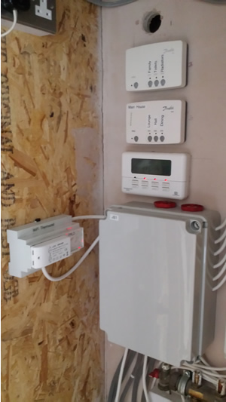
Danfoss receivers

This timer is normally not used (i.e. set permanently on)
WiFi Thermostat Controller

JB1

The original (and fallback) thermostats are Danfoss TP5001RF with their associated RX3 receivers. If the IoT system is not working these will control the various room temperatures. If it is working they should be set to 'Freeze Protection' mode with a reasonable (say 10C) temperature setting. To disable the IoT system control the WiFi Thermostat should be turned off.
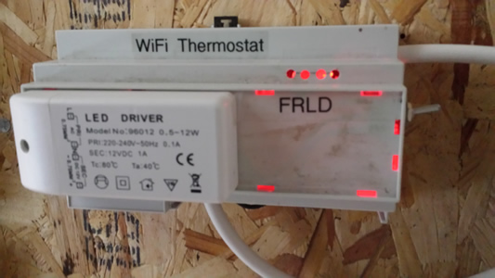
On/Off switch

Note that the Danfoss thermostats that are normally disabled are listed in brackets on the diagram. The temperatures measured by the various WiFi Thermostats are transmitted via the MQTT broker to the IoT.js control program. These values are stored (in the MySQL database) and monitored to control the heating system valves. These valves are operated electronically from the WiFi Thermostat Control unit and the WiFi Thermostat/Rad Controller. The signals to operate these are transmitted via the MQTT broker.
LEDs that indicate which valve is being operated. (not easy to make out!)

Diagnostics
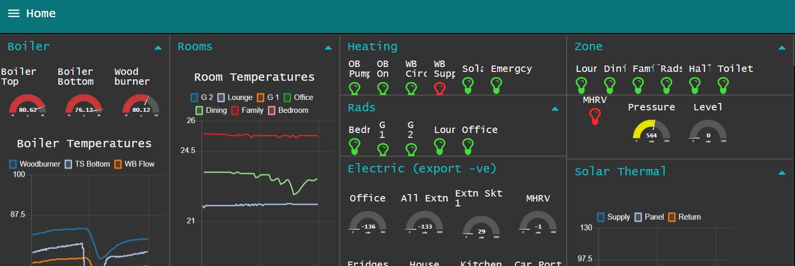
The most useful diagnostic tool is the 'Hollies IoT Dashboard' (192.168.1.100:1880)

From this you can easily see whether to Thermal Store temperatures are sensible, Room temperatures are what you'd expect, and the pumps and control valves are being set as expected. If anything looks wrong you can double check with a mains detector (magic wand) and also that valves are not stuck (as they are prone to do as the heating is brought into use in the autumn.

There is now a setting for if the Oil Boiler is out of action for more than an hour or so. It ensures that the Central Heating pumps don't operate if just the immersion heater is on.

Solar Thermal (HHS/7)

Parts
Part | Description
Solar panels (GREENSKIES SOLAR-LITO MINI) | 3 Panels in parallel, feed from bottom. There is a 4th but there is no room to fit it
Panel temperature sensor | DS18B20. Is on its limits if no circulation on a hot day
AAV | Automatic Air Vent; except needs to be manually opened (?!). Useful to avoid air lock
Pipework | The main pipework is 10mm. This avoids having too great a volume of cold water put through the Solar Coil when the pump starts. It may make it more likely that the glycol (antifreeze) goes gloopy if the panels over heat
Insulation | As far as possible the pipework is insulated with Armaflex
Drain valve | Used to largely drain the system (some will be left in the Solar Coil). It is also part of the filling loop (See Set Up)
Supply Temperature sensor | DS18B20. Gives an indication of the liquid entering the Solar Coil
Solar Coil | Heat exchanger within Gledhill Thermal Store
Return Temperature sensor | DS18B20. Gives an indication of the liquid leaving the Solar Coil
Loop Close Valve | Used to force liquid through the pipework and panels using the Filling Pump
Pump | DC12V 480L/H Solar Hot Water Pump Circulation This is a centrifugal rather than diaphragm pump as it is quieter
Flow Sensor | Used for calculations and to ensure pump does not run dry
Pressure Sensor | Information only
Tap | Used to help drain the system. Also can have mechanical water Pressure gauge attached
Filling Loop | Consists of a valve, check valve and 12v pump (12V 130PSI 6L/Min High Pressure Diaphragm Self Priming Water Pump). This type is chosen because it can pressurise the system.
Pressure Relief Valve | 3 bar
Electric Valve | This operates in parallel with the circulation pump and is closed when the pump is off to ensure there is no thermal circulation e.g. at night
Expansion vessel | Use to maintain system pressure
Solar Controller | This controls the Circulation Pump by monitoring the various temperature and flow sensors. It is linked via WiFi to the IoT Manager

Parameters
Parameter | Value | Usage
Flow Time | 10 | # seconds pump runs for if no flow detected. (not used)
Flow Pulses per Litre | 450 | Used to measure energy
Panel Temp Diff | 20 | How much hotter the panel needs to be against the Thermal Store

Controls
Switch Actions:
Config ON | # Presses | Action
Yes | Flows & Temperatures are printed (5 secs)  LED doesn't flash in background  After presses LED flashes Action # (of presses)
Yes | 1 | Print Values
Yes | 2 | Publish Temperatures
Yes | 3 | Start/Stop Web configuration (if not doing Smart Config)
Yes | 4 | -
Yes | 5 | Start/Stop Smart Config configuration
No | LED flashes according to Pump State (See below)
No | 1 | Print Values
No | 2 | Stop Pump override
No | 3 | Start Pump override
No | 4 | Resume pump automatic operation
No | 5 | -

Note that the pump will stop after 10 seconds of zero flow in automatic mode or 30 seconds in override mode.

Pump States:

State | LED | Description
PUMP_OFF_NORMAL | 1 short flash | Pump in auto mode and OFF
PUMP_ON_NORMAL | 2 long flashes | Pump in auto mode and ON
PUMP_OFF_OVERRIDE | 3 flashes | Pump overridden - OFF
PUMP_ON_OVERRIDE | 5 flashes | Pump overridden - ON

Set Up
Warning – if this process is performed on a sunny day the liquid temperatures can easily exceed 50C.

To fill the system use a 5l container of water plus solar glycol antifreeze and use a flexible pipe to the Filling Pump. Ensure the Filling Loop manual valve and Loop Close Valve are open and also open the Drain Valve with another pipe to the 5l container. It is also worth having a flexible pipe from the PRV into the container in case the pressure goes over 3 bar. Start the Filling Pump the, soon after, start the Circulation Pump so as to open the Electric Valve. You will probably need to restart the Circulation Pump after 30 seconds as there will have been no liquid through the Flow Sensor. Let this continue until liquid with no bubbles is coming out of the Drain Valve then stop the Filling Pump.

Close the Drain Valve and let the pressure rise to at least 1 bar (using the pressure gauge). Go to the AAV and open it until no air is being released. Leave the Circulation Pump running (or restart it) for at least a minute to ensure liquid is flowing round the system. Return the Circulation Pump to automatic mode. Check the pressure over several days to ensure there is no leakage.

The 'Panel Temp Diff' setting is fairly critical in getting the right balance between getting the most energy out of the panels and not losing energy by starting the Circulation Pump to quickly and ending up cooling the Thermal Store with the cold liquid in the pipes.

Monitoring
The performance of the Solar Thermal system can be monitored in real time using the IoT Manager Dashboard (See 'Hollies IoT System'). Open the Solar Thermal pane to see a graph of the Panel, Supply and Return temperatures. The Thermal Store (TS) Bottom temperature is also of interest. The Heating/Solar indicator shows when the circulation pump is running.

For longer term monitoring use the graphing facility which can also give you an indication of energy production. This is derived from the Flow Sensor and the difference in temperatures of the Supply and Return.

Diagnostics
The IoT Manager gives access to the Alarms, Errors and status of the Solar Controller. You may need to restart the Controller if it seems to have stopped reporting.

Check the various temperatures (Panel, Supply & Return) to see whether they make sense. (They may have come disconnected, misplaced or faulty)

If the pump doesn't run when you would expect it to:
- Start the pump in Override mode and check a) it runs for more than 30 seconds, b) use the IoT Manager graphing to check the flow rate when the Pump is running, c) check the connections to the pump and electric valve.
- Given the small diameter of the pipes it maybe if the liquid has gone gloopy you may need to flush out the pipes. Use the filling pump with the Loop Close valve closed and the electric valve open (i.e. the pump override active) to force clean water round the system. Then refill with solar glycol mix.

